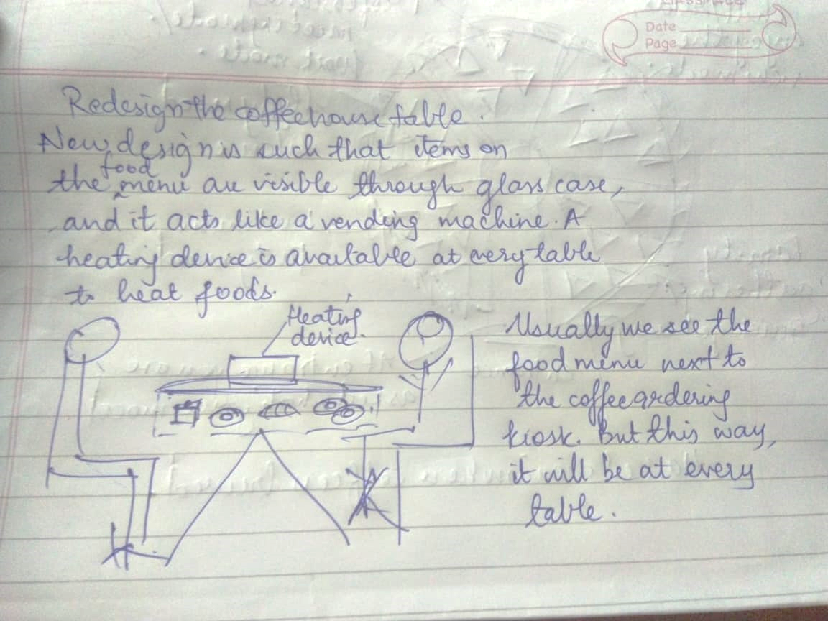

We usually see the food menu where we order the coffee. In my suggestion, food will be placed under the tables within a glass case and there will be a vending machine-like mechanism to order the food you want. A heating device placed on the table so you can heat your food.

1. Relocate the food items
2. Convenient for the customer, he won’t have to call the waiter
3. Convenient for coffee house owner since seeing food in front of them will tempt customers to order food and hence could lead to increase in revenue
4. There can be a system to track the food left in the glass case, so more food can be prepared and added in the machine
5. No hassle of money exchange since ease of using a vending machine.